What I did this week:

I am working on the write-up of the new implementations:

- chessboard corner detection

- auto-reshaping the pre-anamorphic image

- least squares method for the two-viewer system

But I haven’t gotten very far with that.

I also did some testing on the two-viewer thing, and the results are a bit worrisome because one camera seems to have a much more “straight” image than the other:

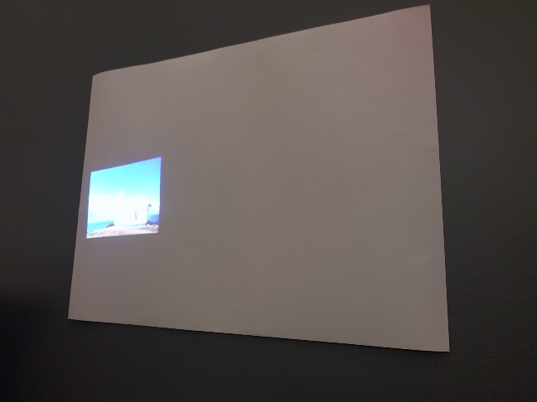 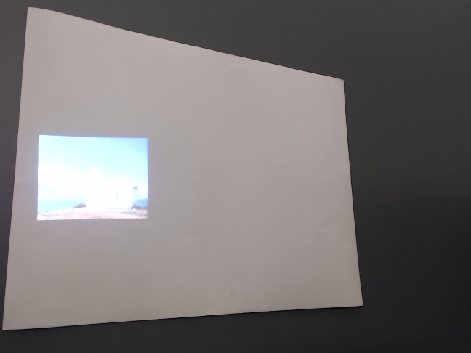

camera 1 camera 2